PRELIMINARY FORM
II International conference
«PROBLEMS OF ANIMALS STUDY AND
PROTECTION IN THE NORTH »
Name…....................................................................……
Surname...................................................................…...
⇨ Mr. ⇨ Ms
Mailing address …………………………….…………..
Postal code ……………………………………………..
City……...........................................................................
Country..………………………………………………
Phone .....................................……….…….…....………
Fax....................................E-mail……………………….
Title of paper………………………………….……….
…………………………………………………………
Authors………………………………………………….
……….………………………………………………….

COULD YOU PLEASE NOTE THE NUMBER OF
MAIN THEME AND FORM OF PARTICIPATION:
 lecture
 oral presentation
 poster
 discussion
Accompanying Person(-s) ……………………………….

All correspondence with participants will be carried out only by e-mail

PUBLICATIONS
Papers should not exceed three A4 pages (including tables and literature). You can send printed and electronic version (by e-mail attachment) to the secretary (animals@ib.komisc.ru). Please, note in title of attachment surname of first author (Petrov.rtf). Papers should be sent before the October 10, 2012.

INSTRUCTIONS FOR AUTHORS
Please, use the standard format MS Word (*.rtf), letter type Times New Roman, 12 pointtype, line distance 1, all margins – 2 cm. The beginning of the first paragraph line should intent (1.27 cm). All Latin names of species and genera must be italicized.

THE TITLE SHOULD BE CAPITALIZED AND
CENTERED
I.I. Ivanov1, N.N. Nikolaev2 – 1 empty lines off, clarendon italic centered.
1 Syktyvkar State University, Syktyvkar,e-mail: italic
centered.
2 Institute of Biology Komi SC, Syktyvkar, e-mail: italic
centered.

Text (lower-case letters, without hyphenation of words, justification on width of line) should be printed in single column 1 empty lines off.
LITERATURE
Odum U. Ecology. M., 1986. Vol. 1. 328 p.
White J. The plant as a metapopulation // Ann. Rev.
Ecol. Syst. 1979. № 10. P. 104–145.

Every participant of the conference may be author of one paper and co-author of not more than two papers.
The book of papers will be published before the beginning of the conference.
Organizing committee will not deal with papers, which not correspond theme and aims of conference
or incorrectly formalize.

RUSSIAN ACADEMY OF SCIENCES
Ural Branch
Komi Scientific Centre
Institute of Biology

Ural Branch
Institute of Plant and Animal Ecology

Scientific council on wildlife research,
protection and management

Ministry of Nature Resources and
Environmental Protection of Komi

Federal service for supervision of nature management in the Republic of Komi

UNDP/GEF Project «Strengthening Protected
Areas System of the Komi Republic
To Conserve Virgine Forest Biodiversity
in the Pechora River Headwaters Region»

II INTERNATIONAL CONFERENCE

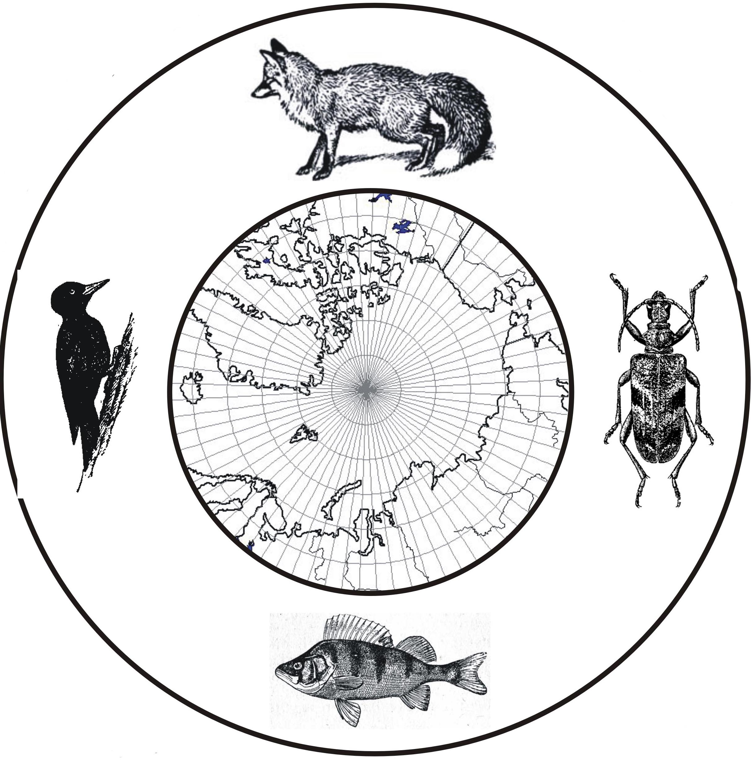

PROBLEMS OF ANIMAL’S STUDY
AND PROTECTION IN THE NORTH

April, 8-12, 2013
Syktyvkar, the Komi Republic, Russia

First Circular

DEAR COLLEAGUE!
We would like to invite you on the II International
conference “PROBLEMS OF ANIMAL’S STUDY AND PROTECTION IN THE NORTH”. It will be held in Syktyvkar (the Komi Republic, Russia),
April, 8-12, 2013.

WE HOPE FOR YOUR ACTIVE PARTICIPATION IN THE CONFERENCE AND WILL BE GLAD TO WELCOME YOU
TO SYKTYVKAR – THE CAPITAL OF THE
KOMI REPUBLIC.

Dr. Svetlana Degteva
Chairman of the Organizing Committee,
Director of Institute of Biology

The program will include lectures on different themes by a number of invited scientists, also oral
and poster presentations by scientists and PhD students. The problems of study of vertebrate animals and also soil, terrestrial and aquatic invertebrates in the North will discuss on the conference.

SCIENTIFIC PROGRAM
1. Fauna, taxonomy, zoogeography and adaptations of animals in the North
2. Structure and dynamics of animal’s communities and populations in the North ecosystems
3. Influence of natural and anthropogenic factors on the animal’s fauna and population
4. Protection of animals in the Protected Areas

THE OFFICIAL LANGUAGES OF THE CONFERENCE WILL BE RUSSIAN AND ENGLISH.

SCIENTIFIC COMMITTEE
Bogdanov V.D. (Russia, Ekaterinburg) – chairman
Ivanter E.V. (Russia, Petrozavodsk)
Striganova B.R. (Russia, Moscow)
Lisin Yu.V. (Russia, Syktyvkar)
Popov A.N. (Russia, Syktyvkar)
Bolotov I.N. (Russia, Arkhangelsk)
Sinev S.Yu. (Russia, St. Petersburg)
Yakovlev V.A. (Russia, Kazan)
Novoselov A.P. (Russia, Arkhangelsk)
Dolgin M.M. (Russia, Syktyvkar)
Mineev Yu.N. (Russia, Syktyvkar)
Ponomarev V.I. (Russia, Syktyvkar)
Kurhinen Yu.P. (Finland, Helsinki)
Mennobart Van Erden (the Netherlands, Lelystad)

ORGANIZING COMMITTEE

Degteva S.V. (Russia, Syktyvkar) – chairman
Dolgin M.M. (Russia, Syktyvkar) – co-chairmen
Baturina M.A. (Russia, Syktyvkar) - secretary
Loskutova O.A. (Russia, Syktyvkar)
Estafjev A.A. (Russia, Syktyvkar)
Zakharov A.B. (Russia, Syktyvkar)
Kochanov S.K. (Russia, Syktyvkar)
Tatarinov A.G. (Russia, Syktyvkar)
Shubina V.N. (Russia, Syktyvkar)

REGISTRATION FEES
Participants .......................……...………….….100 Еuro
PhD students ...………………………………....50 Еuro
Payment should be made before the November 1, 2012

ACCOMODATION
Organizing Committee will handle hotel accommodation near the conference site. Information about prices of hotel will be in second circular. Accommodation suggestions will be accepted before the March 1, 2013.

TRANSPORTATION
Syktyvkar is connected by airlines and railway with
many cities of Russia. The time of flight from S.-
Petersburg and Moscow is 1 h 40 min. The time of
railway travel from Moscow to Syktyvkar is 27 h.
Attention please, plains fly and trains go every day.

ADDRESS OF THE ORGANIZING
COMMITTEE
Institute of Biology Komi SC UВ RAS
Kommunisticheskya st., 28,
Syktyvkar, 167982, Russia
Maria Baturina
CONTACTS
Phone: 8 (8212) 436384
Fax: 8 (8212) 240163
Е-mail: animals@ib.komisc.ru
Site: http:ib.komisc.ru/add/conf/animals_2013
DEADLINE DATA
Preliminary form .............................September 20, 2012
Submission of papers ...........................October 10, 2012
Registration fee...................................November 1, 2012
Second Circular ….....................................January, 2013
Accommodation…….……………….......March 1, 2013
Registration ……...............................April 8th-9th, 2013
Beginning of the Conference …...………..April 9, 2013

