Third international conference “Advances in the biology of shrews III”
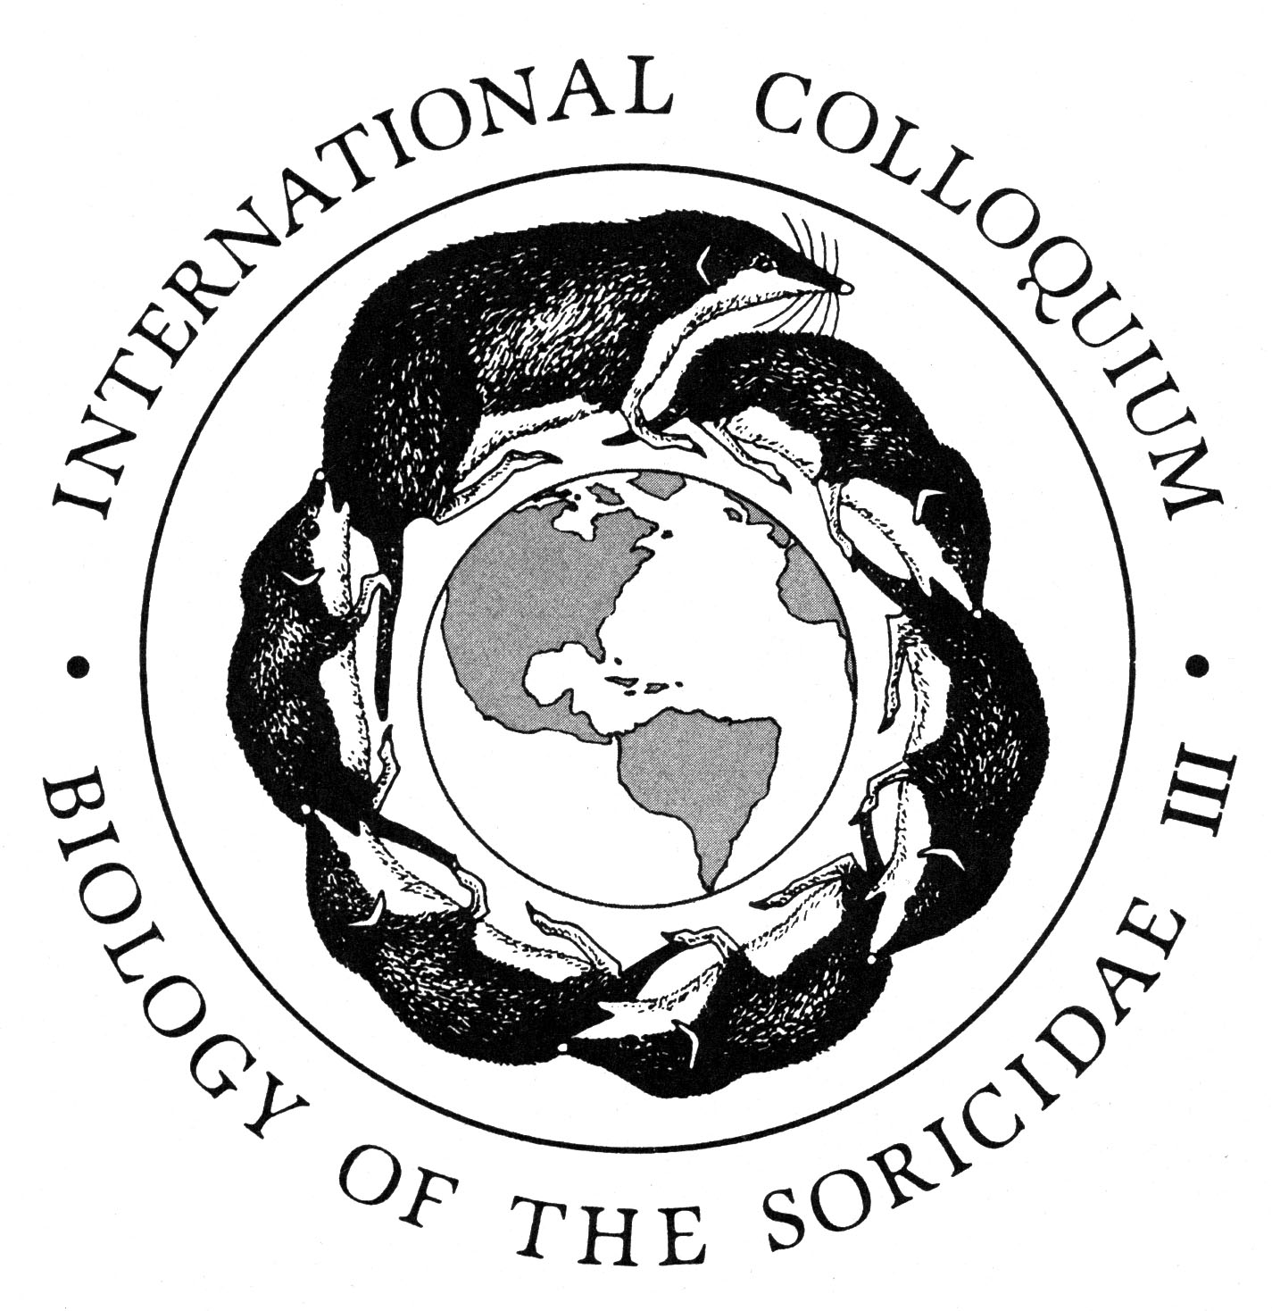
Second circular

RUSSIAN ACADEMY OF SCIENCES

Institute of Biology of Komi SC UB RAS

A.N. Severtsov Institute of Ecology and Evolution RAS

Russian Theriological Society

Symposium Announcement

«Advances in biology of shrews III»

Convened during the

International Year of Biodiversity

14 -17 September 2010

Syktyvkar, Komi Republic, Russia

Main themes:
- Morphology and systematics
- Zoogeography
- Molecular and genetic diversity
- Ecology
Thematic symposia and round-table discussions are welcome. Poster sessions will also be considered.
Suggestions concerning the organization of the symposia are valuable and should be submitted before 10 May 2010.
The symposium will be held from 14-17 September 2010 at the Institute of Biology of Komi Scientific Centre of Ural Branch Russian Academy of Sciences.
Symposia, round-table discussions and poster sessions are proposed in the framework of the conference.
Registration fee (publication and organization of meeting): $350 (students and postgraduates – $150).
Registration fee can be paid in cash on the day of registration.
Travel: from Moscow (Avia or train to Syktyvkar).
Accommodations: Yugor hotel, Syktyvkar hotel, hunting lodge

Steering Committee:
- Merritt J. F., Prof., INHS, University of Illinois. Chairman (USA)
- Taskaev A.I., Dr., Director of Institute of Biology. Chairman (Syktyvkar, Russia)
- Rozhnov V.V., Prof., Deputy Director of A.N. Severtsov Institute of Ecology and Evolution. Chairman (Moscow, Russia)
- Bannikova A.A., Dr., Moscow State University (Moscow, Russia)
- Bobretsov A.V., Dr., Pechoro-Ilychski reserve (Russia)
- Carpenter S., Illinois Natural History Survey, University of Illinois (USA)
- Churchfield S., Dr., Department of Anatomy and Human Sciences, King's College London (UK)
- Dokuchaev N. E., Prof., Institute of Biological Problems of the North (Magadan, Russia)
- Foresman K. R., Prof. The University of Montana, (USA)
- Haberl W., Dr., Oekoteam - Institute for Animal Ecology & Landscape Planning (Vienna, Austria)
- Kalinin A.A., Dr., A.N. Severtsov Institute of Ecology and Evolution (Moscow, Russia)
- Kochanov S.K., Dr., Institute of Biology (Syktyvkar, Russia)
- Kouprianova I.F., Dr., Pechoro-Ilychski reserve (Russia)
- Kouptsov A.V., Dr., A.N. Severtsov Institute of Ecology and Evolution (Moscow, Russia)
- Litvinov Yu. N., Prof., Institute of Systematic and Ecology of Animals (Novosibirsk, Russia)
- Pavlova S.V., Dr., A.N. Severtsov Institute of Ecology and Evolution (Moscow, Russia)
- Polly P. D., Prof., Indiana University (USA)
- Poroshin E.A., Dr., Institute of Biology (Syktyvkar, Russia)
- Shchipanov N.A., Prof., A.N. Severtsov Institute of Ecology and Evolution (Moscow, Russia)
- Sheftel B.I., Dr., A.N. Severtsov Institute of Ecology and Evolution (Moscow, Russia)
- Taylor J. R.E., Prof., University of Bialystok (Bialystok, Poland)
- Turlejski K., Prof. Nencki Institute of Experimental Biology (Warsaw, Poland)
- Wojcik J. M., Prof., Director of Mammal Research Institute, Polish Academy of Sciences, (Bialowieza, Poland)
Steering committee requests abstract submission no later than 10 May 2010 using the form below and attachments to e-mail shrews3@mail.ru: Surname and given name, title, position, address, e-mail, title of presentation – specify oral or poster presentation.
Address of the steering committee: A.N. Severtsov Institute of Ecology and Evolution, Leninski prosp. 33, 119071 Moscow, Russia. Phone: +7(499) 135-98-85, fax +7 (495) 952-35-84. More information: www.sevin.ru (http://www.sevin.ru/menues1/index_eng.html).

Important:

You should submit your abstract via email shrews3@mail.ru with "Abstract" in the subject line.
Please submit abstracts in English
If written in Russian, the title and summary must be in English

Title - Arial, Bold, 14 pt.
Presenting Author¹underlined, Arial, 12 pt., Co-authors Arial, 12 pt. Author 2² Author 3¹, etc. Bold, Italic
¹Institution, City, Country (Arial, 12 pt.,), e-mail
²Institution, City, Country, e-mail
Abstract. Arial, 10 pt, Abstract (no more than 200 words).

Example for English version:

Diet of the common shrew S. araneus in “Zelenaia Roshcha” woodland in vicinity of Cherepovetz
E. S. Stepina, N.Ya. Poddubnaya, I.P. Cherniaeva
Cherepovetz State University, Cherepovetz, Russia, StepinaElena@yandex.ru

Studying food habits in dominant species of small mammals is of great importance for estimating the role of a species in the structure and function of an ecosystem. The common shrew (S. araneus) is the dominant species in Vologodskaia area. Our study was conducted in the vicinity of Cherepovetz, Russia, etc. NOTE: Abstract should include the principal objectives, methods employed, summary of results, and a brief statement of the principal conclusions.

Example for Russian version:

Diet of the common shrew S. araneus in “Zelenaia Roshcha” woodland in vicinity of Cherepovetz
E. S. Stepina, N.Ya. Poddubnaya, I.P. Cherniaeva
Cherepovetz State University, Cherepovetz, Russia, StepinaElena@yandex.ru

Питание обыкновенной бурозубки (Sorex araneus) лесного массива «Зеленая роща» окрестностей г. Череповца
Е.С. Степина, Н.Я. Поддубная, И. П. Черняева
Череповецкий государственный университет, г. Череповец, Россия, StepinaElena@yandex.ru

(The high percentage of vegetation items in diet (31%) was found which is uncommon. Females prefer more calorific food as compared to males (27% in females versus 17% insect larve in males). The common shrew is considered centralistic species which included in diet the most available food objects).
Изучение питания фоновых видов животных – одна из ключевых задач для оценки состояния естественных экосистем и последующего рационального управления ими. Доминирующим видом бурозубок лесных экосистем Вологодской области является обыкновенная бурозубка (Sorex araneus). И.т.д.

