VI Congress of Russian Society of Plant Physiologists

First Announcement

VIth Congress of Russian Society of Plant Physiologists

International Conference
«The modern plant physiology: from molecules to ecosystems»
18-24 June 2007
Syktyvkar, Komi Republic, Russia

Congress OrganizErs

●Russian Academy of Sciences
●Division of Biological Sciences RAS
●Russian Society of Plant Physiologists
●Scientific Council of Russian Academy of Sciences
on Plant Physiology and Photosynthesis
●Institute of Biology, Komi Science Centre,
Ural Division of RAS
●Institute of Plant Physiology RAS
●Ministry of Education and Science
of Russian Federation
●Syktyvkar State University

OrganiZing CommitTee

Co-Chairpersons:
Prof. T.K. Golovko; Prof. Vl.V.Kuznetsov; Dr A.I.Taskaev, Director of the Institute of Biology
●
Dr N.G.Buchov; Dr S.N.Chmora (secretary);
Academician RAAS V.A.Dragavtsev; Prof. I.P.Ermakov;
Prof. Yu.V.Gamalei, Corresponding Member RAS; Prof. V.V.Ignatov; Dr V.P.Kholodova;
Prof. V.N.Khryanin; Prof. V.V.Klimov; Prof. O.N.Kulaeva; Dr V.V.Kuznetsov;
Prof. S.S.Medvedev; Prof. A.M.Nosov; Academician Yu.S.Ovodov; Prof. G.A.Romanov;
Prof. R.K.Salyaev, Corresponding Member RAS; Academician I.A.Tarchevsky;
Prof. A.A.Tikhomirov; Prof. A.F.Titov, Corresponding Member RAS;
Prof. N.N.Tretyakov, Corresponding Member RAAS; Prof. T.I.Trunova;
Dr V.L.Tsydendambaev; Prof. B.F.Vanyushin, Corresponding Member RAS; Prof. A.P.Veselov; Dr V.V.Volodin; Prof. V.K.Zhirov, Corresponding Member RAS; Academician U.N.Zhuravlev.
MAIN TOPICS

- Plant Cell EnergeticS and Metabolism
- Plant Genome and Regulation OF ITS EХpression
- Hormones and Ontogenesis
- Stress, Adaptation and Survival of Plants
- Ecosystem Physiology and Global Ecology
- Phytosystems of THE Russian North
- Plant Cell Biology and Biotechnology
- Transgenic Plant Biology
- PLANT ProductivITY
- Teaching in Plant PHYSIOLOGY

CONTACTs

Institute of Biology, Komi Science Centre, Ural Division of RAS
28, Kommunisticheskaya St.
Syktyvkar, 167982, Komi Republic, Russia
tel.: (8212) 24-96-87; (8212) 24-52-02
fax: (8212) 24-01-63
e-mail: plant_phys@ib.komisc.ru
http://www.ib.komisc.ru/plant_phys2007
Please assist us in our planning by indicating your intention to attend.
Please complete this form.

VI Congress of Russian Society of Plant Physiologists
(June 18-24, 2007, Syktyvkar)

REGISTRATION FORM

Family name
First name
Patronymic name (if applicable) _____________________________________________________
Male / Female __________________________________________________________________
Date of birthday
Title (Dr / Prof)
Organization/Institute
Position
Postal address (including postcode)
_______________________________________________________________________________
Tel.
E-mail
Fax
Presentation title
_______________________________________________________________________________
_______________________________________________________________________________
Authors (presenting author underlined) _______________________________________________
Main topic (number)
Oral/poster
Date
Signature

Attention!
Please send you registration form by September, 2006
by e-mail: plant_phys@ib.komisc.ru or by ordinary mail to:
Institute of Biology, Komi Science Centre, Ural Devision of RAS
28, Kommunistycheskaya St.
167982 Syktyvkar, Komi Republic, Russia

KEY DATES
●First Announcement February-March 2006
●Deadline for Registration September 15, 2006
●Second Announcement September 2006
●Deadline for submission of Abstracts February 1, 2007
●Programme Congress April 2007
●Abstract publication May 2007
●Arrival and registration June 18-19, 2007
●Opening Congress June 19, 2007
●VI Congress June 19-23, 2007
●Social Programme June 23-24, 2007
●Departure June 24-25, 2007

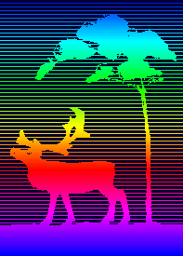 THE INSTITUTE OF BIOLOGY of the Komi Science Centre, Ural Division, Russian Academy of Sciences is the biggest academic centre of ecological and biological investigations in the Europaean North-East of Russia. The staff includes 184 scientists among them 111 Professors and Doctors, and 35 Postgraduate Students. The basic research directions are biodiversity, stability and productivity of taiga and tundra ecosystems; biological impacts of low doses of ionizing radiation; multidisciplinary studies of biologically active compounds in plants; development of approaches monitoring and bioindication.
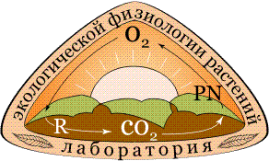 THE LABORATORY OF THE ECOLOGICAL PLANT PHYSIOLOGY conducts research into the physiological-biochemical basics of adaptation and reproduction of natural and cultural plant species to cold climate conditions.
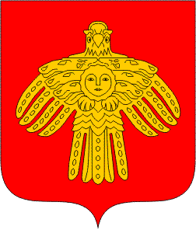 The REPUBLIC of KOMI is an equal in rights subject of the Russian Federation. The area of Komi is 416,800 km² (2.4% in the total area of Russia). The population totals 1018,679 (0.7% in the population of Russia). The Republic is rich in mineral and biological resources.

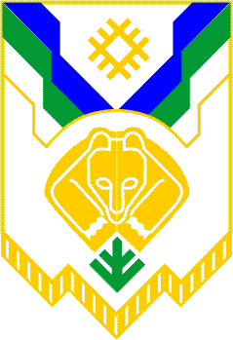 SYKTYVKAR is the capital of the Republic of Komi. Syktyvkar is located in the European North-East of Russia in the middle taiga subzone. It is an administrative, economic, cultural and important industrial centre. Syktyvkar is well connected to Moscow and Saint-Petersburg by airline and railway. The usual time of transfer from Moscow and Sankt-Peterburg is 1 h 40 min (by plain), and 26 and 37 h (by train). Travel by bus from Kirov to Syktyvkar (8 h) is also possible. SYKTYVKAR has moderately continental climate. Main June temperature is 13-15^{о} С.

